THE UNIVERSITY OF DODOMA

COLLEGE OF INFORMATICS AND VIRTUAL EDUCATION
DEPARTMENT OF COMPUTER SCIENCE AND ENGINEERING (CSE)
LAB THREE: EMAIL FORENSICS
PROGRAM: BSc-CNISE
COURSE: IA 418
SUBMISSION DATE : 26th January 2025

GROUP PARTICIPANTS
NAME | REGSTRATION NUMBER
NYAMIZI SHIJA | T22-03-02725
PUDENCIANA P. KIYEGA | T22-03-11584
EMMANUEL WOLFGANG | T22-03-09178
GEORGE KALAMU | T22-03-08400

LAB THREE DEMOSTRATION.
By refering from Lab 2 we saw how to install the mail server “Mail enable” and “Thunderbird”. So Here we continue with how to get domain where for us we get it from the cloudflare. Since we have a domain already we will just log in to continue with our demonstration as follow.

STEP 1: Log in your domain server in cloudflare.
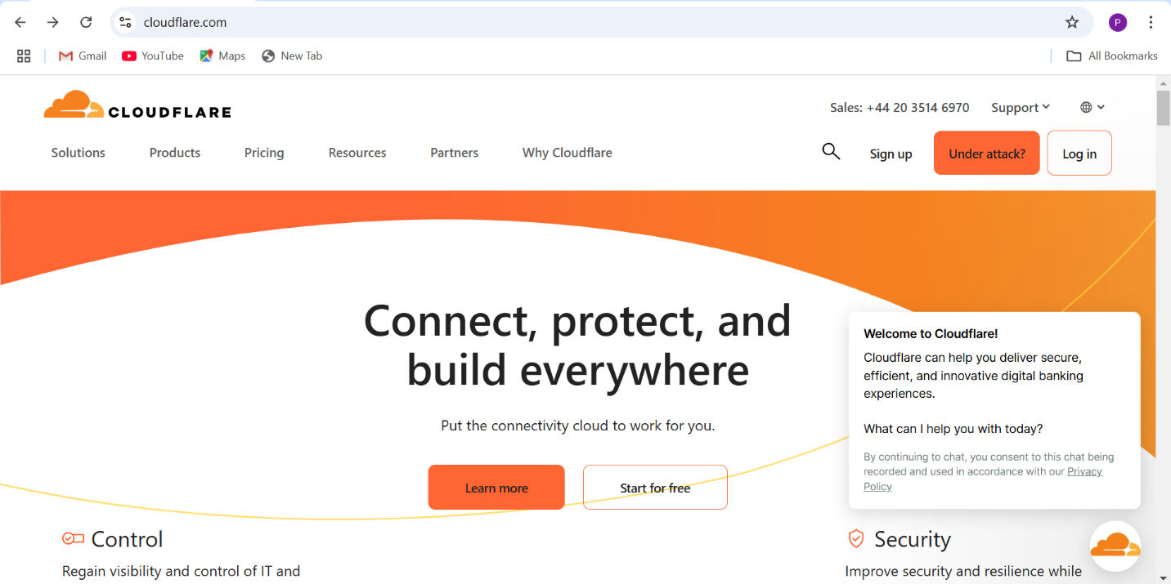

- Here you click on your domain server to set records required .
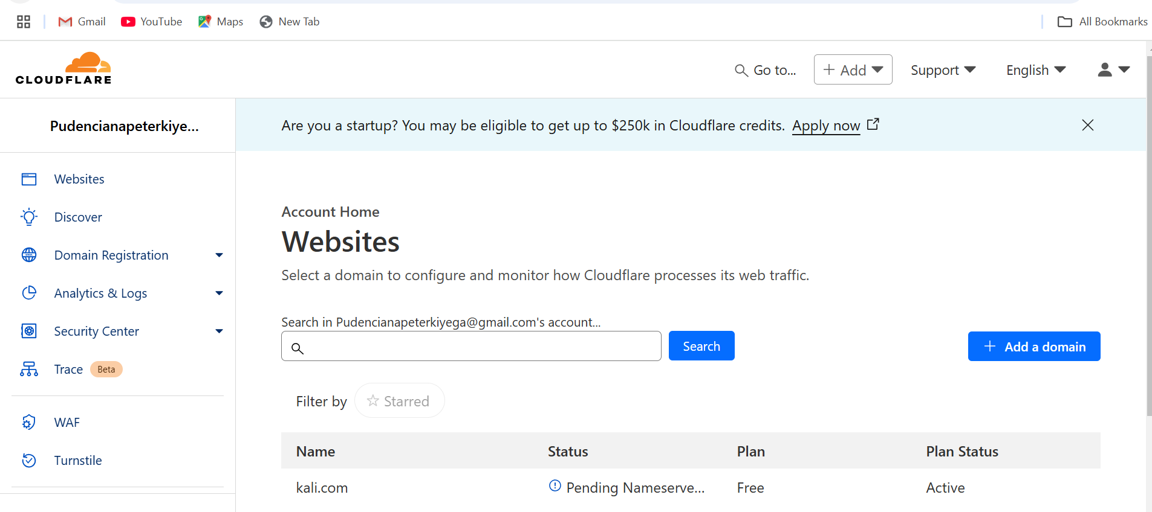
- Click on the Add record tab to start adding DNS records to implement email authentication mechanisms.
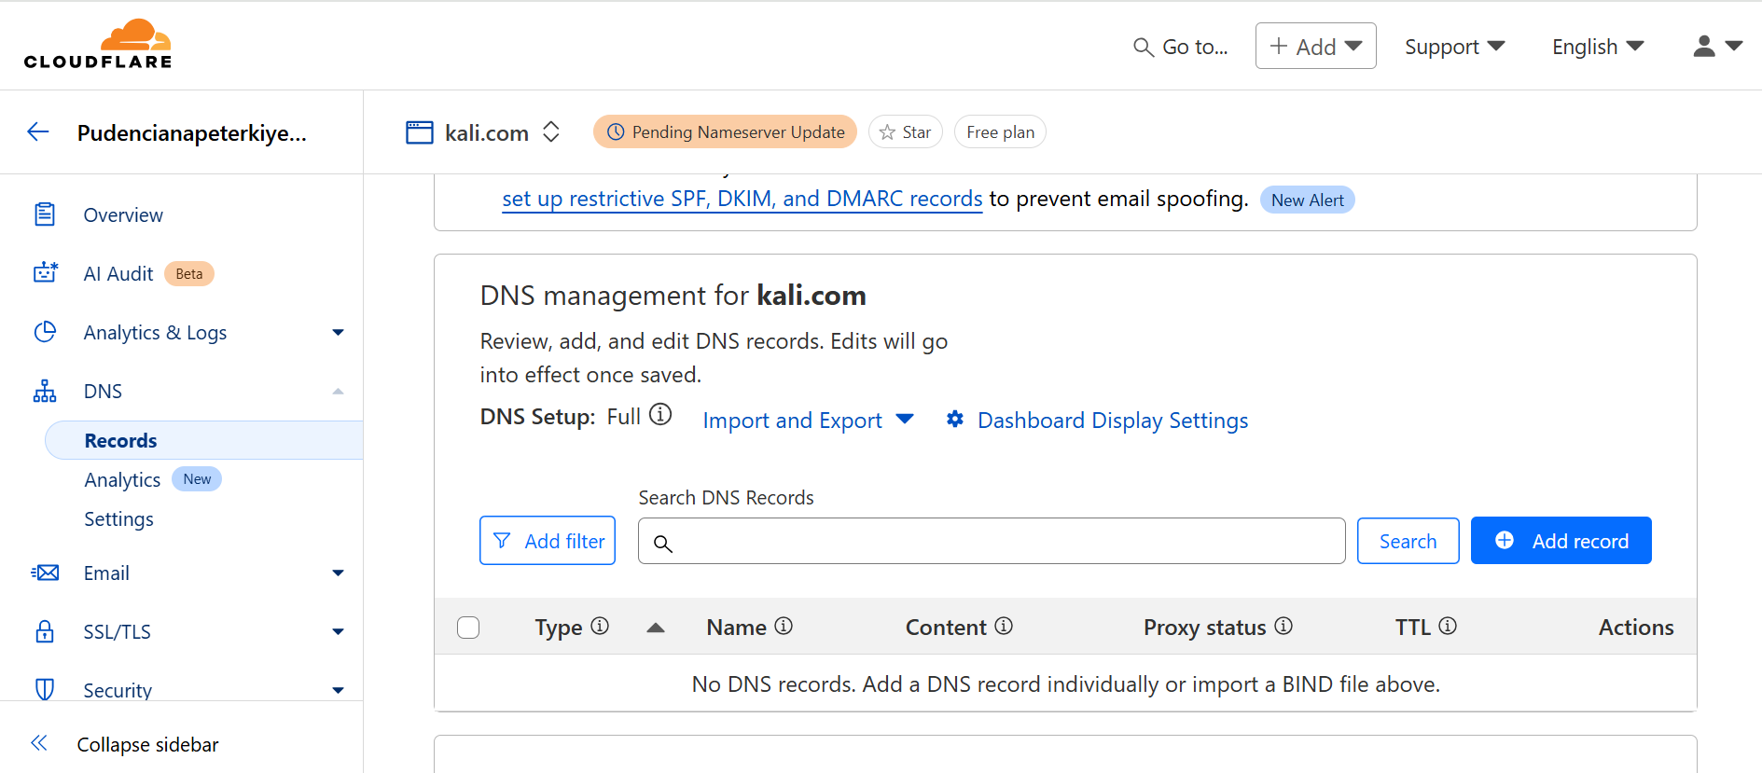

STEP 2: Here we add Sender Policy Framework, it allows domain owners to specify which domain server are authorized to send emails on behalf of their domain.
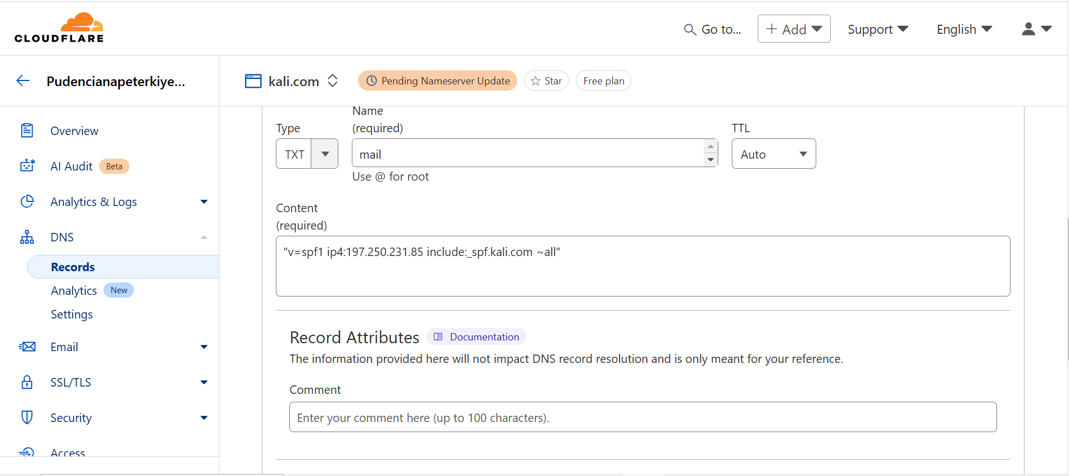

STEP 3: Domain Keys Identified Mail (DKIM), it adds digital signature to emals that can be verified by the receiving mail server.

- First we generate key in command prompt using the command in the figure belows.
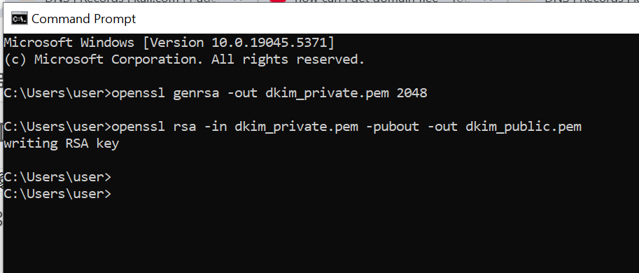

- Here are the keys added private and public keys that are stored in the path “C:\Users\user”
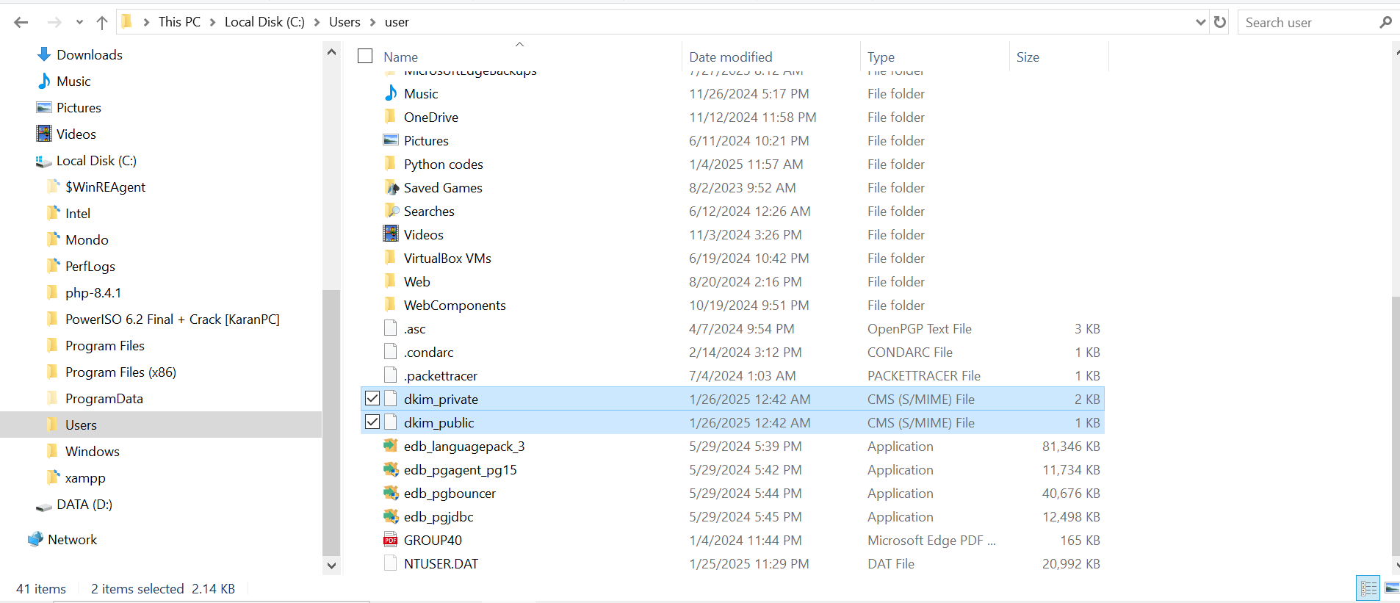

- This is the public key generated by DKIM.
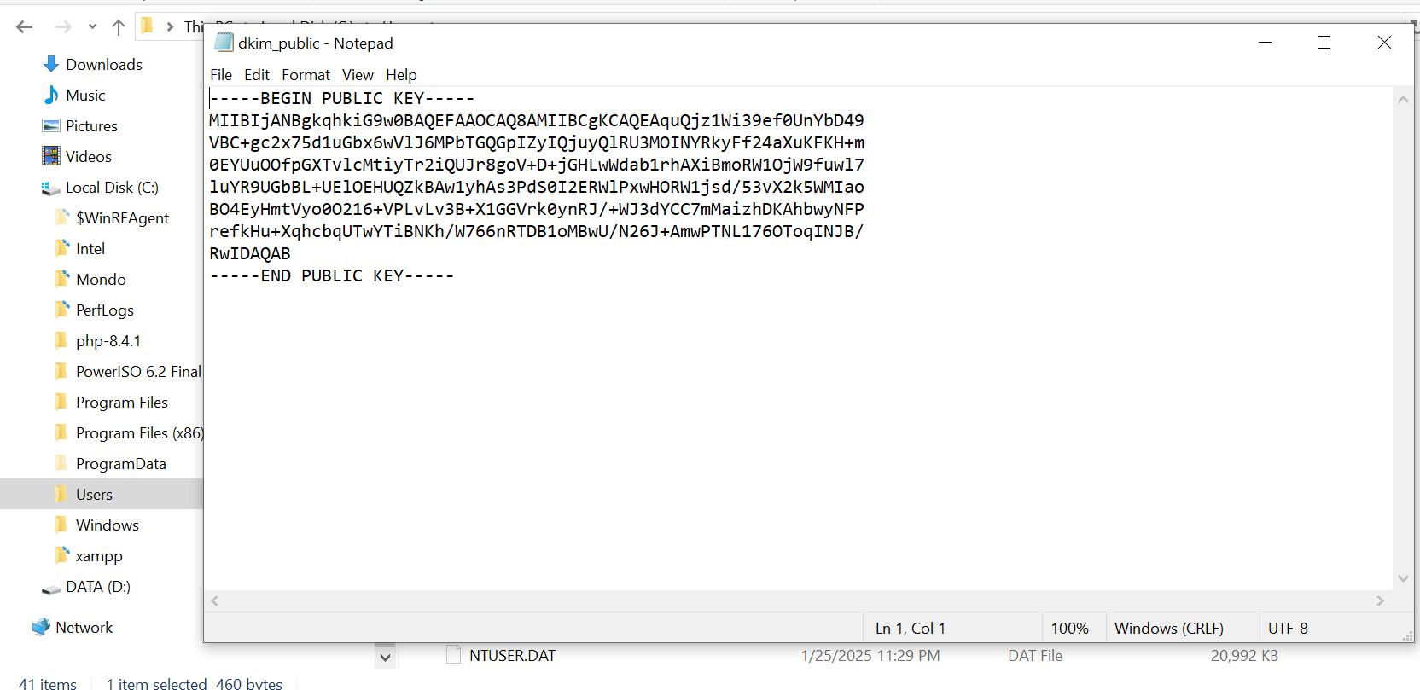

- This is the syntax of adding the DKIM.
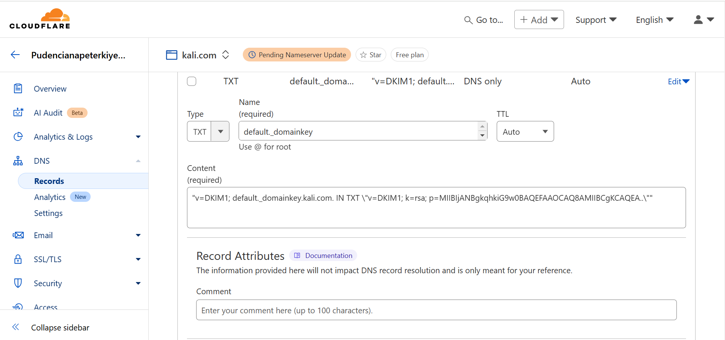

STEP 4: Domain-based Message Authentication Reporting and Conformance (DMARC), it integrate SPF and DKIM to give domain owners more control over how emails failures are handled. Below is the syntax to add DMARC .
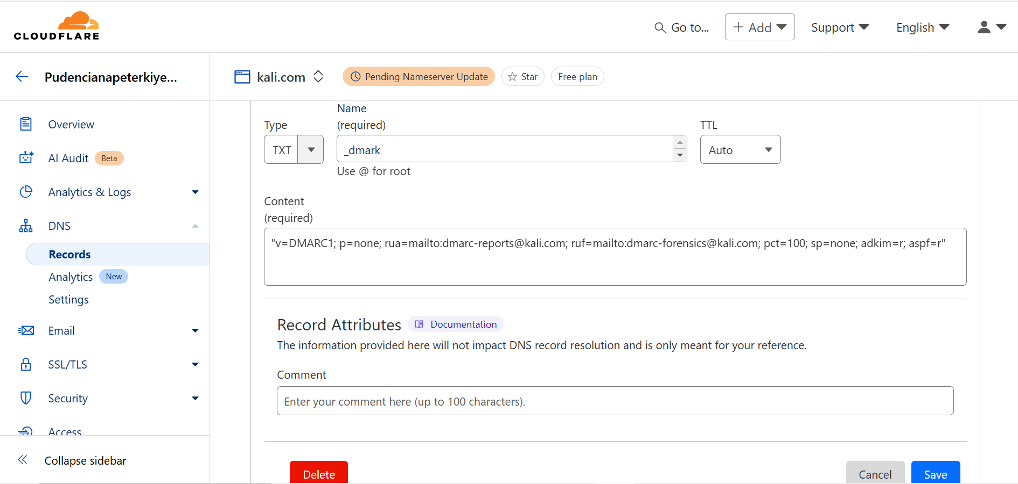

- The following are the records added as seen belows.
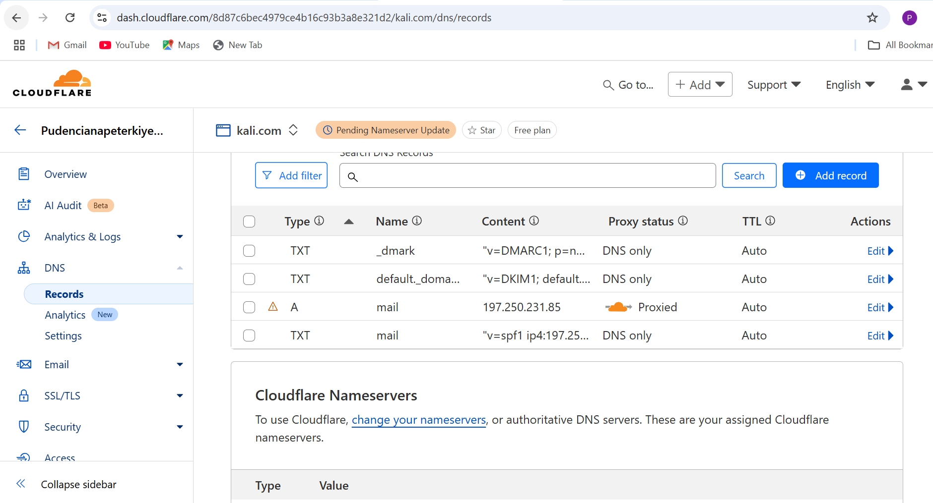

STEP 5: Open mail enable then add the domain server kali.com
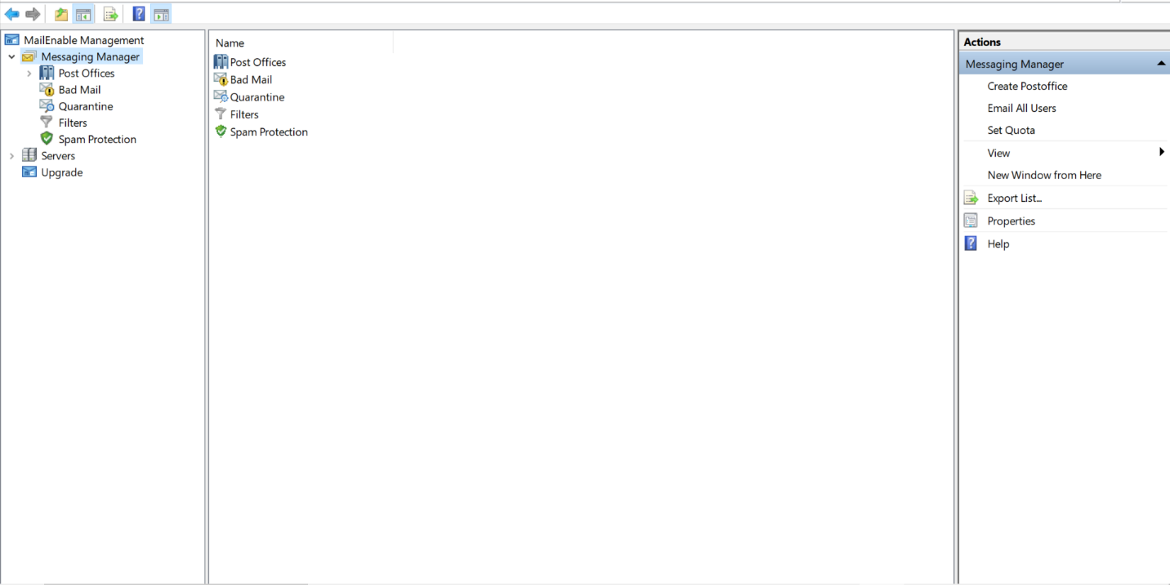

- The domain server is added successful when you click ”ok” as seen below.
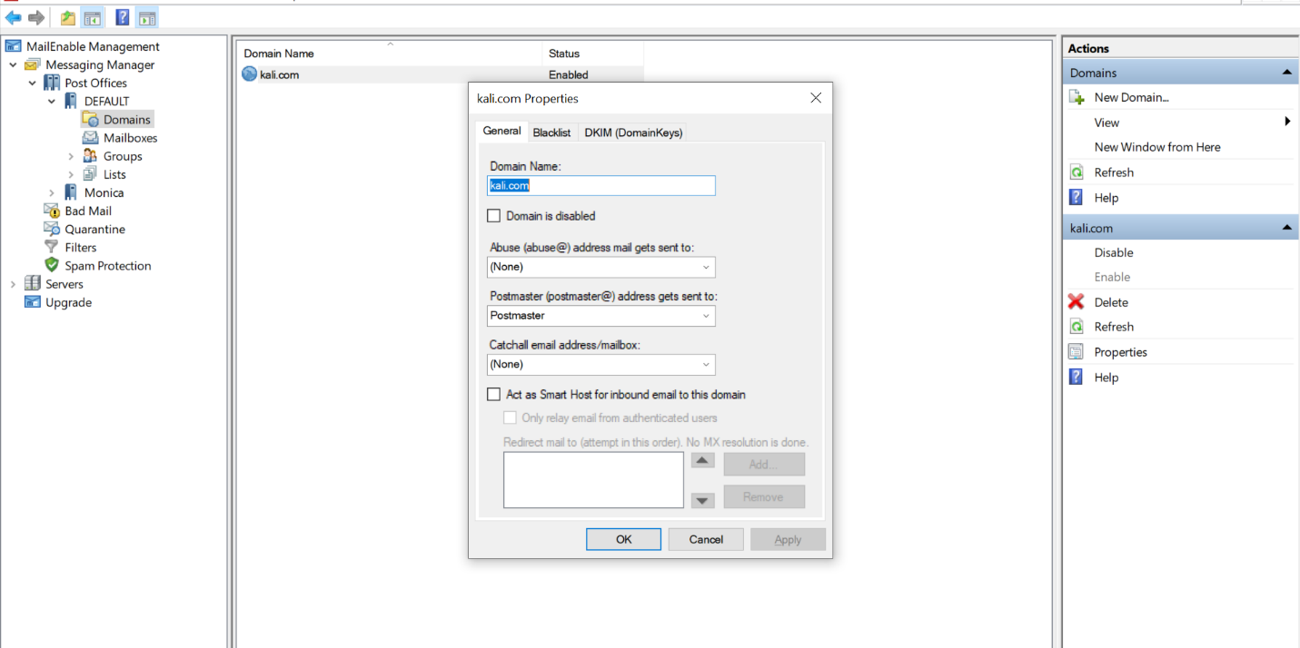

STEP 6: Then add two users in the mail enable that will be sender and receiver. Here we set name and password of the user then click OK.
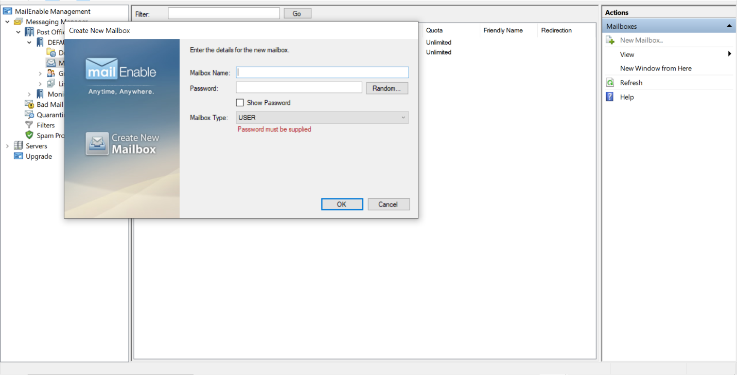

- Users are added successful as seen below
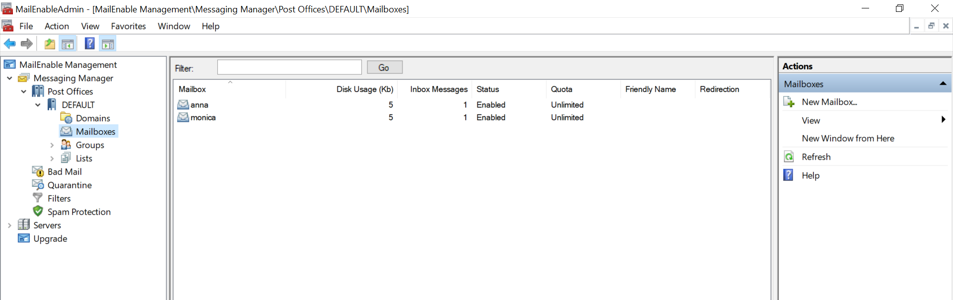

STEP 7: Add users in thurderbird as seen below .
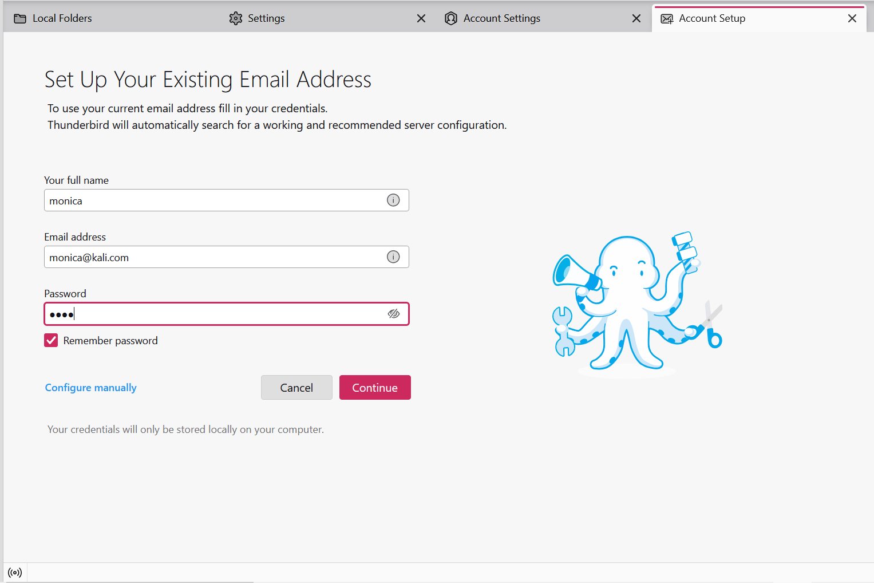

- Set protocol, hostname as localhost, port 110 for POP3 and 25 for the second port then retest.
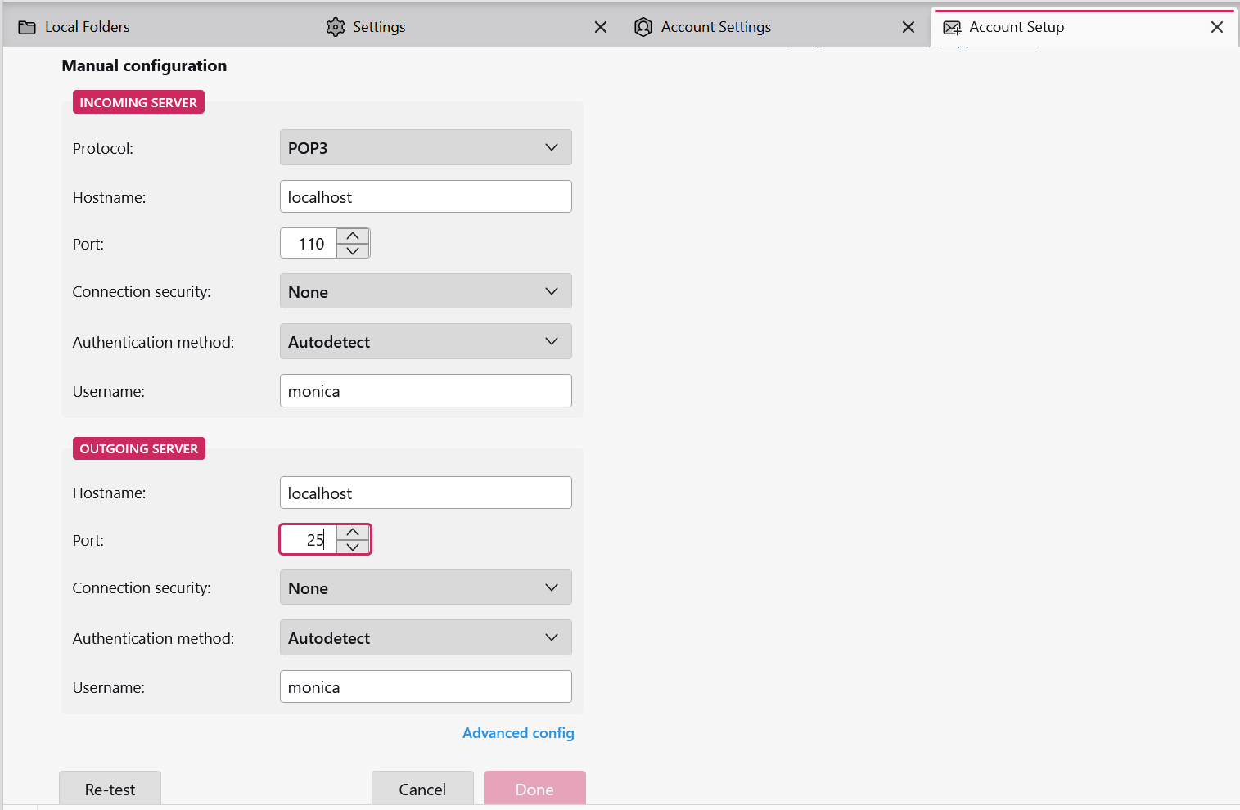
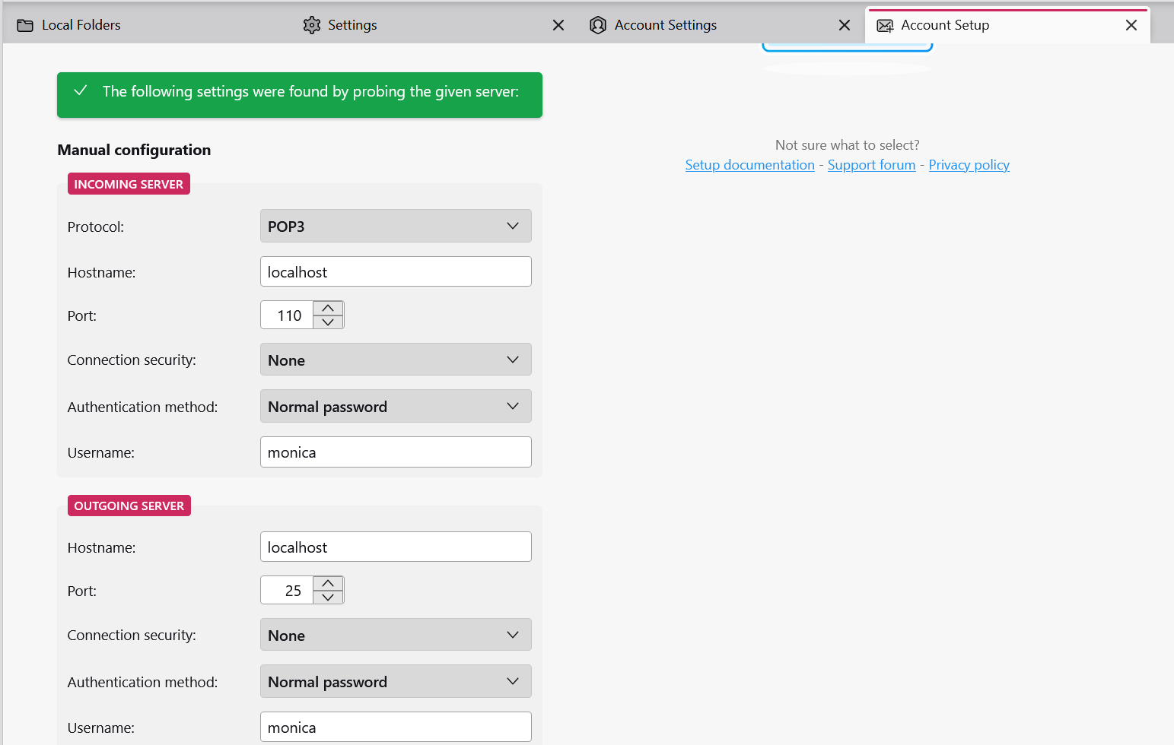

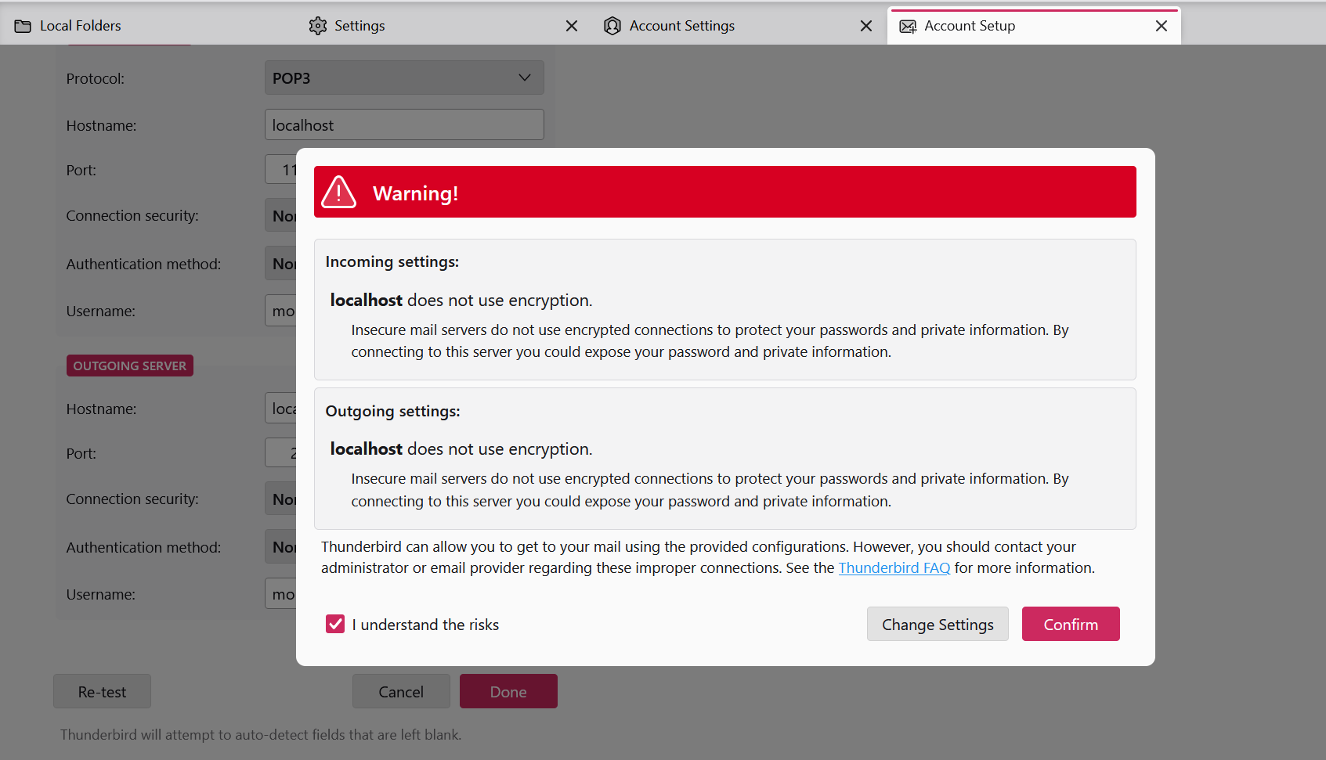

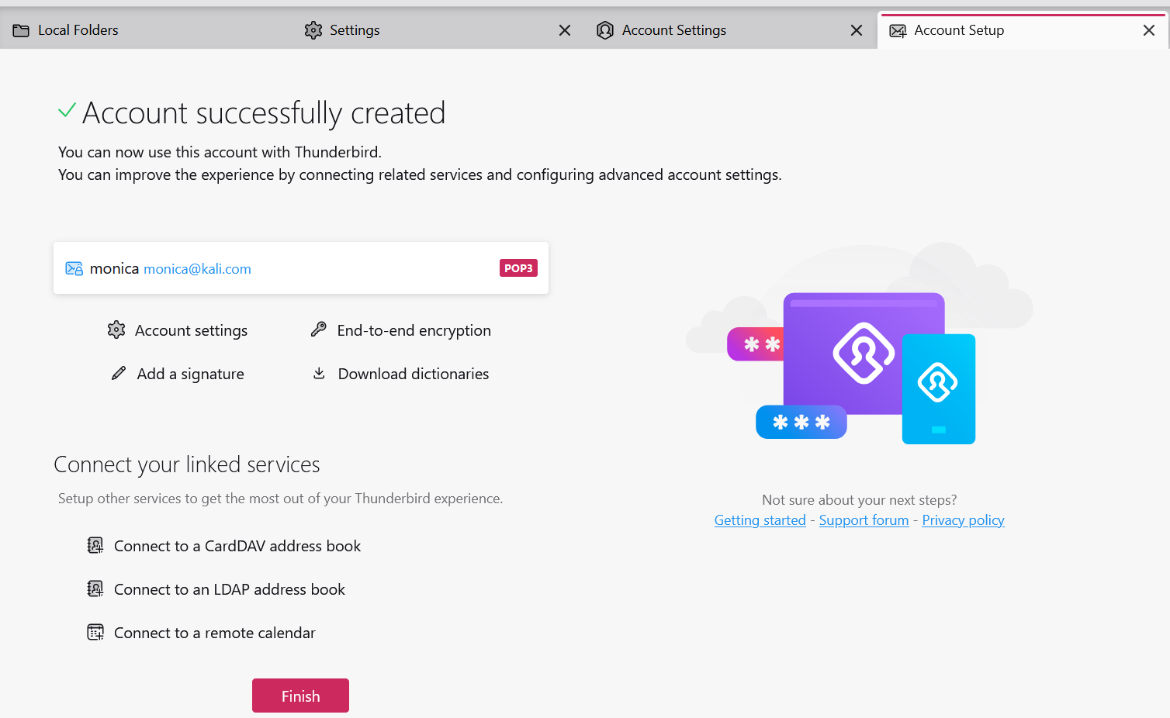

- Repeat the same steps to create second user hence the figure below show the users added to the thunderbird.
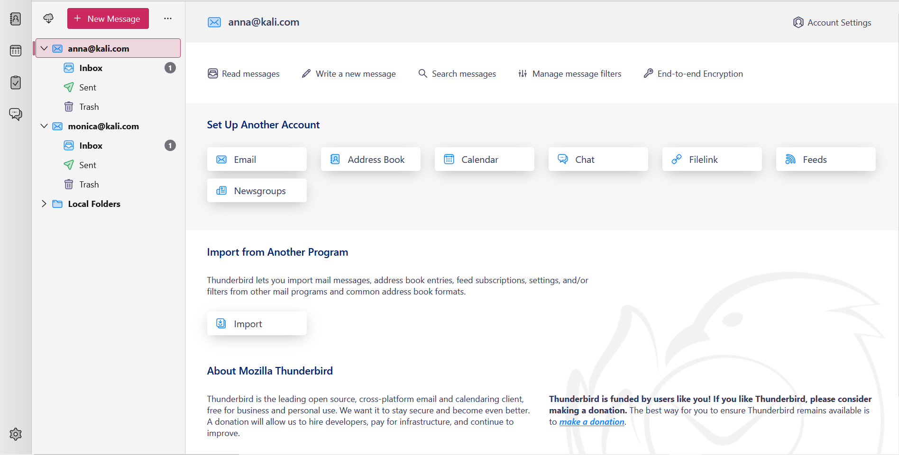

STEP 8: Here you can write message from anna and send to monica as seen below.
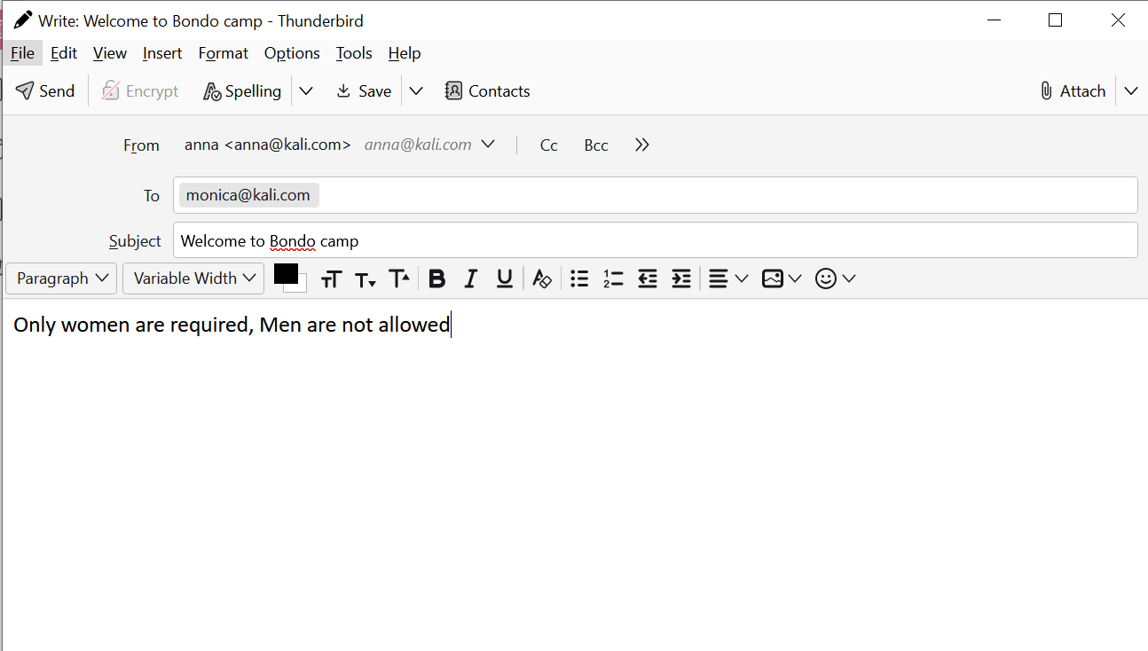

- Message received to monica successful as seen below.
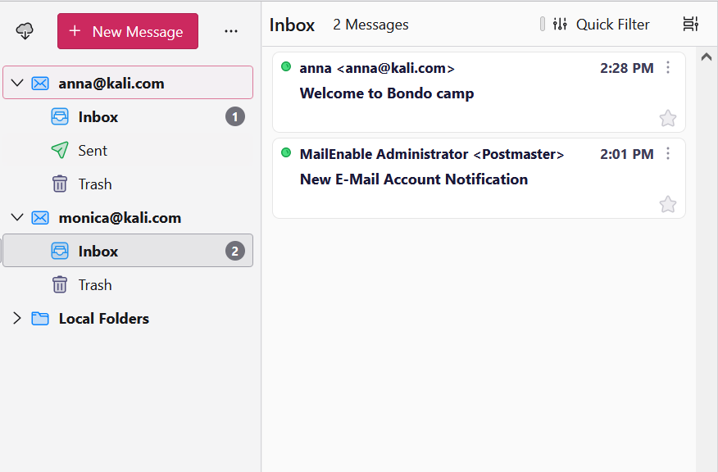
- Here monica replys and send to anna again .
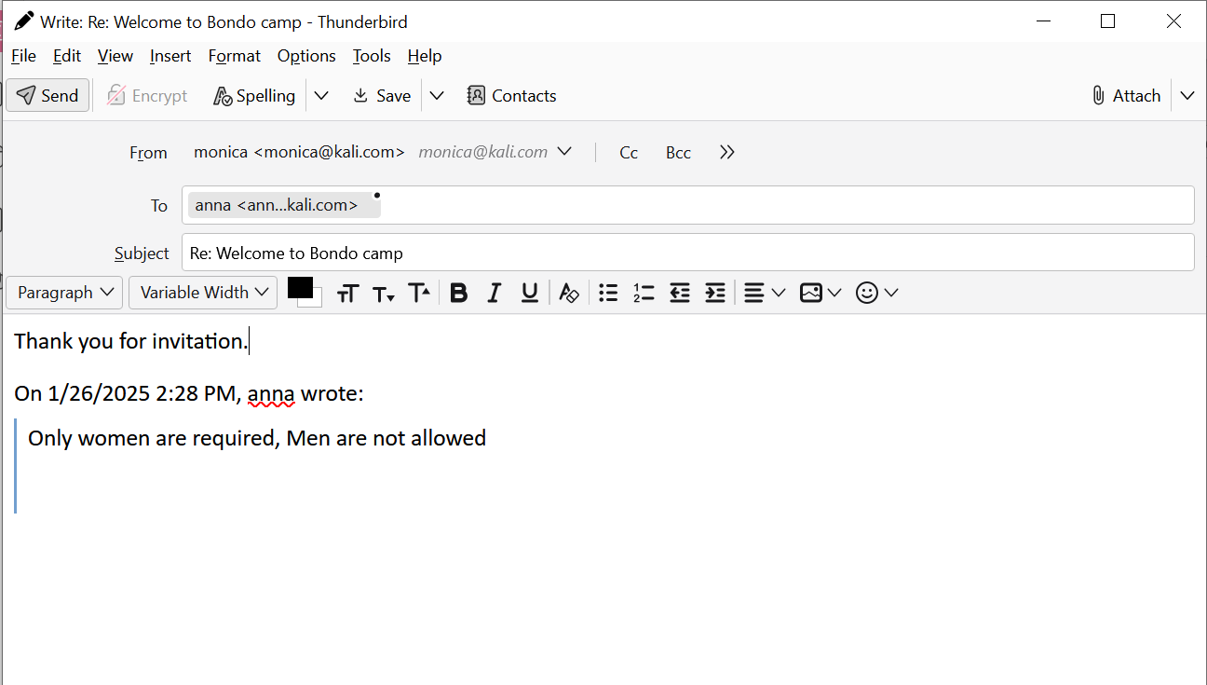

- Message received to anna successful as seen below.
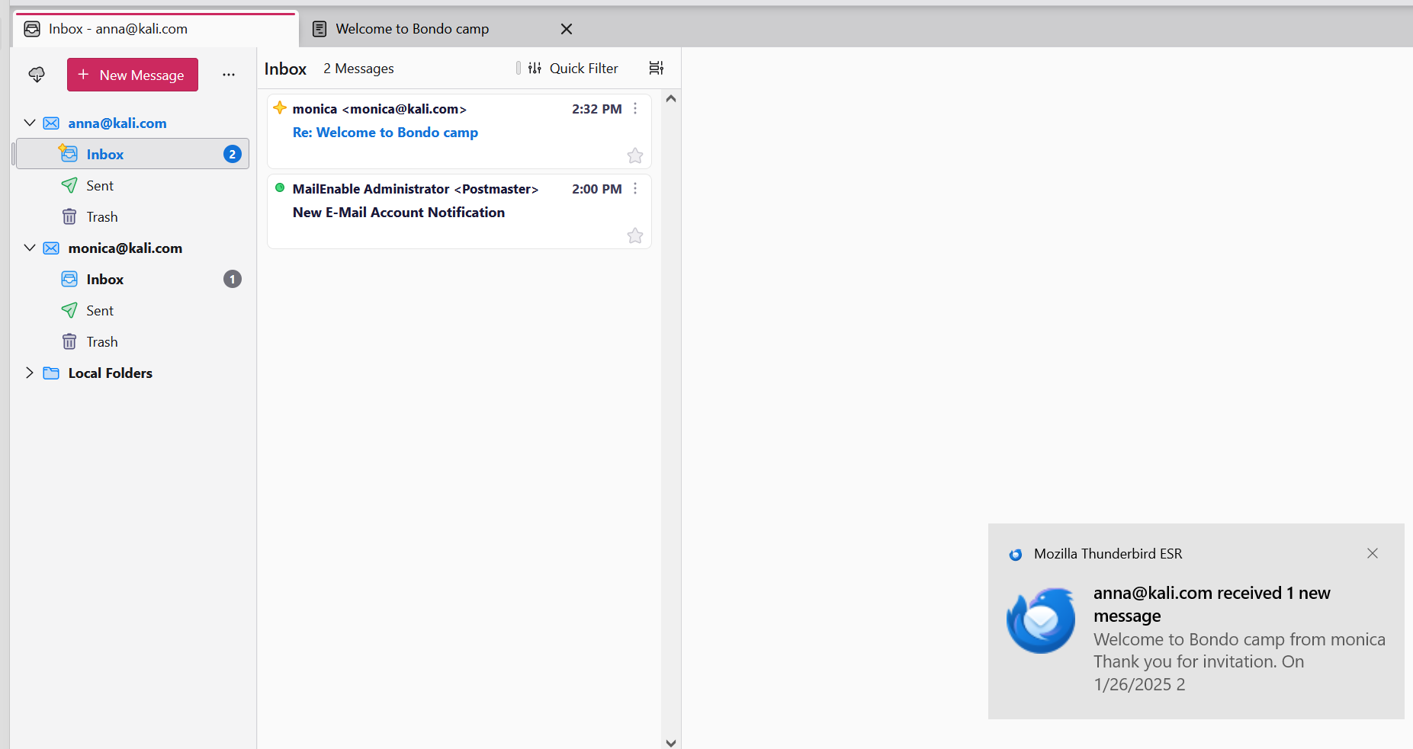

- he provided email headers contain metadata and technical details about the email as handled by Mozilla Thunderbird and other systems. Here we see X-Account-Key: account4 that refers to the internal account identifier in Thunderbird, indicating which email account received the email and X-UIDL: 74178C3FE74147998906D1A79D40CC99 that is the unique identifier for the email on the server. It helps Thunderbird determine whether the email is new or already downloaded. Those header can be used to authenticate the emails sent.
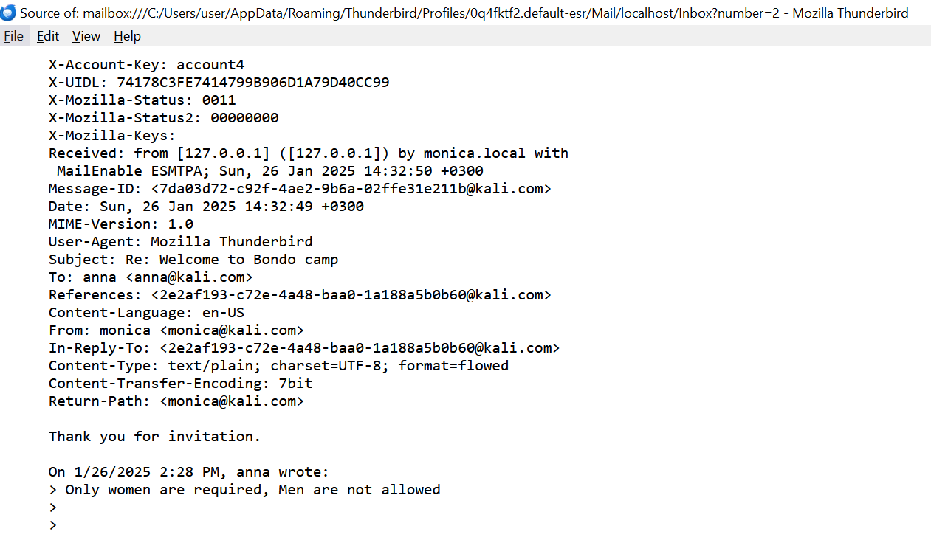

- Security of Emails with SPF, DKIM, and DMARC SPF, DKIM, and DMARC significantly improve email security by making it much harder for attackers to spoof emails. However, they don't provide absolute protection.
QN: Can Emails Still Be Spoofed?
Answer:
Yes, emails can still be spoofed even with SPF, DKIM, and DMARC in place. Here's why:
• DMARC Policy of "none": A DMARC policy of "none" only monitors failed emails but doesn't prevent delivery. This is often used during initial deployment but doesn't provide full protection.
• Subdomain Spoofing: Attackers might try to spoof subdomains that don't have DMARC records.
• Misconfiguration: Incorrectly configured SPF, DKIM, or DMARC records can create vulnerabilities.
• Human Factor: Even with strong authentication, users can still be tricked by phishing emails that look legitimate.
• Imperfect Adoption: Not all domains have implemented SPF, DKIM, and DMARC. This leaves a large attack surface for spoofing.

Loopholes and Limitations.
• SPF Limitations: SPF has limitations in handling forwarded emails.
• DMARC Dependence on SPF and DKIM: DMARC relies on SPF and DKIM to function effectively. If either of these is misconfigured or absent, DMARC's effectiveness is reduced.
• DKIM Complexity: DKIM key management can be complex, and weak keys can be compromised

