aa

CG 311: Software Defined Networks
Lecture 01: Introduction
1.3 Overview of SDN
SDN is a network management scheme that decouples the control plane from the data plane. With SDN, network administrators are exempted from dealing with low level functions of network devices (Akyildiz et al, 2014). SDN makes this possible by following the layered architecture depicted in Figure 1.
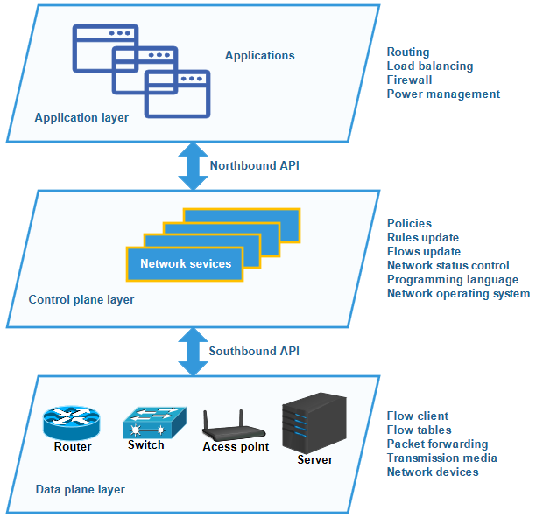
Figure 1: SDN Architecture (Bojovic et al, 2018)
Separation of a control plane from the data plane, make things easier from the perspective of network management and evolution. Experiments on new protocols and applications can now be conducted over the network without affecting unrelated network traffic. Additional infrastructure can be introduced with minimum struggle. In addition, middleboxes can be easily integrated into the software control to allow various proposals for problems, like traffic measurement and management in the complex core of cellular networks (Shu et al, 2016).
In Figure 1, the bottom layer consists of switches, routers, wireless access points etc, these network devices manipulate data packets and flows in order to forward them. In SDN, these network devices referred to as switches do not run switching (such as spanning tree etc) or routing protocols (such as OSPF, BGP etc) because all control logic has been moved to the middle layer. The middle layer is the control plane, which has an entity called a controller. The controller entity is responsible for providing a programmatic interface to the network. Through a controller new functionality can be deployed and management tasks can be performed. For example, a service provider can change the routing protocols simply by configuring a controller in the control plane without affecting network traffic. The control plane in SDN once stripped from the network devices can centralized logically or by employing servers it can physically centralized or decentralized to control the network infrastructure as a whole (Jeong et al, 2017).
The top layer in SDN stack is the application layer, at this layer development and deployment of new applications for different networked environments such as cellular networks, wide area networks, wireless networks etc. can be carried out. To support development and deployment of new applications SDN includes a network operating system. The network operating system acts as an intermediate layer between applications and controller and it is responsible for maintaining a consistent view of network state, which is then exploited by control logic to provide access to various networking services for topological discovery, routing, management of mobility and statistics etc. (Jeong et al, 2017).
By doing this a network operating system gives a general abstraction of network state in switches, revealing a simplified interface for managing the network. This abstraction assumes a logically centralized control model, in which the applications view the network as a single system, which includes all the applications that exploit the services provided by the controller in order to perform network-related tasks, like load balancing, network virtualization etc. (Zhou et al, 2018). In addition, with SDN, even systems like firewalls and Intrusion Detection Systems (IDS) that were part of the network topology, now, they can be implemented in the form of software applications that monitor and modify the network state through the network operating system services.
Finally, the communication of the controller to the data plane and the application layer can be achieved through southbound and northbound API respectively (Shu et al, 2016). Southbound API is for the communication between the controller and the network infrastructure. Northbound API defines an interface between the network applications and the controller. This is analogous to the communication between the hardware, the operating system and the user space in computer systems.
1.3.1 Southbound API
The southbound API provide the way for SDN controller to communicate with switches in order to program the network. The most popular southbound API is OpenFlow (Nick, et al, 2008). However, there are other alternatives such as DevoFlow by Andrew R., et al, (2011) which attempt to solve performance issues that OpenFlow airs. This section will discuss OpenFlow because most projects related to SDN assume that the communication of the controller with the switches is OpenFlow-based (Suzuki et al, 2014). In order to simplify the exchange of commands between a controller and a switch, OpenFlow defines a switch which is composed of two logical components as shown in Figure 2.
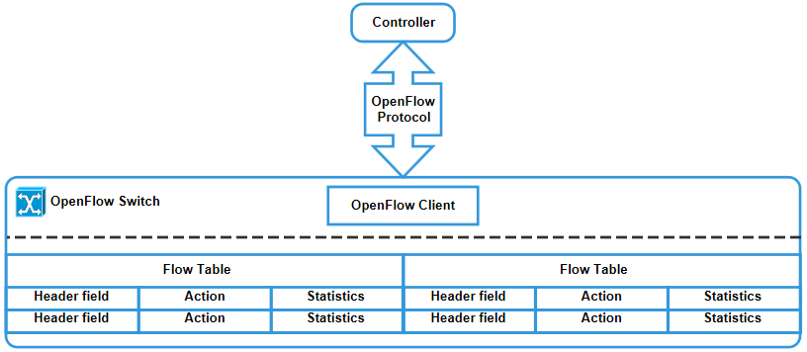
Figure 2: OpenFlow Architecture (Suzuki et al, 2014)
The first component is the flow tables that host information required for forwarding the packets in the switch. The second component is an OpenFlow client, which is a simple API used for communication between the switch and the controller.
According to Suzuki et al, (2014), each entry in the flow table has three fields:
- A packet header defining the flow,
- An Action determining how the packet should be processed and
- Statistics, which keep track of information like the number of packets and bytes of each flow and the time since a packet of the flow was last forwarded.
When a packet arrives at the switch in OpenFlow, the packet header is matched to the flow that has the most similar packet header field. If a matching flow is found, the action defined in the in the flow is performed. The actions in the flow include the forwarding of the packet to a particular port in order to be routed through the network, forwarding of the packet in order to be examined by the controller or the rejection of the packet. For packet that cannot be matched by any flow, OpenFlow includes a miss flow entry which defines an action for them.
At any particular point in time, the controller can manipulate the flows in the flow table by exchanging messages with a switch via a standard secure channel defined by the OpenFlow protocol. That is, the controller can add, update or delete a flow entry either proactively or reactively. Network administrators no longer need to interact with the switch because the controller is able to communicate with the switch using the OpenFlow protocol (Jeong et al, 2017).
1.3.2 Northbound API
Northbound API are provided by a network operating system, they allow network administrator to write high-level services and applications. The high-level services and applications specify high-level policies written by using network-programming languages. The purpose of network-programming languages is to translate high-level policies specified into low-level flow constraints used by controllers to manage the SDN switches. In real sense, the network programming languages act as an intermediate layer placed between application layer and a control layer in the SDN architecture (Suzuki et al, 2014).

